CSIT 321 – Final Year Project

Deep Learning based COVID-19 X-ray Image Classification

Group - FYP-23-S3-07

**Technical Report**

|  |  |
| --- | --- |
| **Name** | **UOW ID** |
| Xie JiangFeng | 7358453 |
| Yin YingCheng | 7083440 |
| Zhang Boyu | 7896505 |
| Tan Wei Yang, Keith | 7366644 |
| Tan Jing Zhi | 7573261 |

**Supervisor:** Mr.Liaw Chun Huei

**Assessor :** Mr.Japit Sionggo

Contents

1. Introduction 3

1.1 Purpose 3

1.2 Objectives of the project 3

1.3 Target Audience 3

2. System Overview 4

2.1 Operating Environment 4

2.4 Design and Implementation Constraints 4

2.1 Work Breakdown Structure 4

3. System Design 6

3.1 User stories 6

3.2 Use Case Diagram 7

3.3 Use Case Description 8

3.4 Class Diagram 16

3.5 BCE and Sequential Diagram 16

3.6 Activity Diagram 23

3.7 Database Design 24

3.71 Identifying Entities 24

3.72 Identifying Attributes 24

3.73 Identifying Attribute Types 25

3.74 Database Design Diagram 25

3.8 Architecture Design 26

3.8.1 Architecture Design Diagram 26

3.8.2 Architecture Design Specifications 27

4. Software Design 28

4.1 Account Features 28

4.1.1 Login 28

4.1.2 Logout 28

4.1.3 Create Account 29

4.2 User: Doctor 30

4.2.1 Upload image for analysis 30

4.2.2 View analysis report 31

4.2.3 Write comments for patients 32

4.2.4 Submit comment/report 32

4.2.5 View previously submitted report 32

4.2.6 Edit comment for previously submitted report. 33

3.2.7 Make report available to the corresponding patient 33

4.2.8 Make report unavailable to the corresponding patient 33

4.3 User: Patient 34

4.3.1 View analysis report and comment from doctor 34

4.3.2 Save analysis report 35

5. Test Plans 36

# Introduction

## Purpose

The purpose of the technical report for this website is to offer an in-depth insight into the underlying architecture, design, and functionality of the platform. It aims to provide a detailed overview for developers, system administrators, and technical stakeholders involved in the project.

The report will outline the technical specifications of the website, including the utilization of advanced Machine Learning techniques, specifically a Convolutional Neural Network (CNN) model, for COVID-19 diagnosis. It will delve into the integration of cutting-edge neural network and image processing techniques to extract intricate patterns from medical images.

Ultimately, the technical report aims to ensure a comprehensive understanding of the website's inner workings, facilitating effective development, deployment, and ongoing management to support accurate and efficient COVID-19 diagnoses.

## Objectives of the project

The project aims to develop an advanced Machine Learning model for more accurate and efficient COVID-19 diagnoses. We analyze existing deep learning models in medical imaging to inform our approach. The enhanced model will utilize cutting-edge techniques in neural networks and image processing to extract detailed information from COVID-19-related medical images. This will assist healthcare professionals and the public in making informed decisions for timely interventions and detection. While the model provides a useful benchmark, consulting a healthcare professional or using alternative testing methods is still recommended for confirmation.

## Target Audience

The project is tailored for healthcare professionals, specifically doctors, who will upload X-ray images for diagnosis using the model. Patients will have access only to view the reports generated by the doctor. Medical related personnel such as healthcare professionals will benefit from the model more from the accuracy and the speed of detection, enabling them to make well-informed decisions and improve patient care.

# System Overview

## 2.1 Operating Environment

|  |  |
| --- | --- |
| **NO** | **Operating Environment** |
| 1 | Computer with web browser installed |
| 2 | Smart phone with web browser installed |

## 2.4 Design and Implementation Constraints

|  |  |
| --- | --- |
| **NO** | **Design and Implementation Constraints** |
| 1 | Users needs full internet access |
| 2 | Users need to have access to a computer or smart phone |
| 3 | User needs to have sufficient computer/smart phone knowledge to use the system smoothly |

## 2.1 Work Breakdown Structure

The boxes filled with orange colour are the core functional requirements that need to be implemented with high priority which includes:

1. X-ray image uploading & removing
2. Image classification
3. Result producing & displaying

It will be desirable but not mandatory that to have:

1. User Authentication & Authorization
2. Advanced result generation
3. Ability to identify other diseases besides Covid-19
4. Report generation & download
5. View previous reports

# System Design

## 3.1 User stories

|  |  |
| --- | --- |
| **Doctor** | |
| 1 | As a doctor, I want to upload X-ray images of patients, so that I can use the backend model to diagnose COVID-19 based on the X-ray images. |
| 2 | As a doctor, I want the model to generate a report with the COVID-19 diagnosis result (positive/negative), so that I can communicate the findings to the patient accurately. |
| 3 | As a doctor, I want to see the results of the machine learning model, so that I can make a diagnosis. |
| 4 | As a doctor, I want the ability to write comments or feedback on the generated report, so that I can provide additional insights or explanations to the patient. |
| 5 | As a doctor, I want to make the report accessible to the patient, so that he/she can review the results, provide feedback and ask questions. |
| 6 | As a doctor, I want to make the report viewable to the patient, so that he/she can gain additional insights on his/her diagnosis. |
| **Patient** | |
| 7 | As a patient, I want to be able check the status of my diagnosis report so that I can track the progress. |
| 8 | As a patient, I want to view the report released by the doctor's model, so that I can know if the X-ray indicates COVID-19 or not. |
| 9 | As a patient, I want to read the comments or feedback written by the doctor, so that I can better understand the diagnosis. |
| 10 | As a patient, I want to print a report of their COVID-19 diagnosis so that I can have a hard copy of the diagnosis for further analysis. |

## 3.2 Use Case Diagram

## 3.3 Use Case Description

|  |  |
| --- | --- |
| **Use Case Name: X-ray Image Upload** | **ID: 1** |
| **Stakeholders and goals:** Doctor aims to upload X-ray images of patients to the website so that the backend model can diagnose COVID-19 based on the X-ray images. | |
| **Description:** Doctor uploads X-ray images of patients for COVID-19 diagnosis. The uploaded images will be processed by the backend model, which will generate a diagnosis report indicating whether the X-ray suggests COVID-19 or not. | |
| **Actors:** Doctor | |
| **Trigger:** The doctor accesses the website and initiates the process of uploading X-ray images. | |
| **Preconditions:**   * The doctor has a valid account registered on the website. * The doctor has relevant X-ray images of patients stored on their device for upload. | |
| **Normal flow:**   1. The doctor selects the option to upload X-ray images for COVID-19 diagnosis. 2. The website prompts the doctor to choose the relevant X-ray images from their local storage. 3. The website processes the uploaded X-ray images and forwards them to the backend model. | |
| **Sub-flows:** None | |
| **Alternative/Exceptional flows:** None | |

|  |  |
| --- | --- |
| **Use Case Name: Report Generation** | **ID: 2** |
| **Stakeholders and goals:** Doctor wants the machine learning model to generate a report with the COVID-19 diagnosis result based on X-ray images, enabling accurate communication of findings to the patient. | |
| **Description:** Doctor uses the machine learning model to analyse the uploaded X-ray images and generate a detailed report with the COVID-19 diagnosis result. The generated report will indicate whether the X-ray images suggest a positive or negative diagnosis for COVID-19, providing valuable information for accurate communication with the patient. | |
| **Actors:** Doctor | |
| **Trigger:** The doctor initiates the process of generating the COVID-19 diagnosis report after uploading the X-ray images. | |
| **Preconditions:**   * The doctor has successfully uploaded X-ray images of the patient to the website. * The uploaded X-ray images have been processed by the backend model. | |
| **Normal flow:**   1. The doctor chooses the X-ray image for which they want to generate the COVID-19 diagnosis report. 2. The machine learning model processes the selected X-ray image and generates a detailed report with the COVID-19 diagnosis result. | |
| **Sub-flows:** None | |
| **Alternative/Exceptional flows:** None | |

|  |  |
| --- | --- |
| **Use Case Name: View Results** | **ID: 3** |
| **Stakeholders and goals:** Doctor wants to view the results of the machine learning model's analysis of X-ray images, enabling them to make a diagnosis based on the provided information. | |
| **Description:** Doctor accesses the machine learning model's results, which are generated based on the analysis of uploaded X-ray images. The results will provide valuable information to the doctor, assisting them in making an accurate diagnosis for the patient. | |
| **Actors:** Doctor | |
| **Trigger:** The doctor initiates the process of viewing the results of the machine learning model after it has analyzed the X-ray images. | |
| **Preconditions:**   * The doctor has successfully uploaded X-ray images of the patient to the website. * The uploaded X-ray images have been processed by the backend machine learning model. | |
| **Normal flow:**   1. The doctor chooses the X-ray image for which they want to view the machine learning model's results. 2. The website displays the results of the machine learning model's analysis for the selected X-ray image. The results may include the COVID-19 diagnosis (positive/negative) and any additional insights or details obtained from the model. | |
| **Sub-flows:** None | |
| **Alternative/Exceptional flows:** None | |

|  |  |
| --- | --- |
| **Use Case Name: Write Comments** | **ID: 4** |
| **Stakeholders and goals:** Doctor wants the ability to write comments or feedback on the generated report to provide additional insights or explanations to the patient regarding their COVID-19 diagnosis. | |
| **Description:** Doctor accesses the generated report and being able to write comments or feedback to improvise the COVID-19 diagnosis. The doctor may include additional details, recommendations, clarifications, or treatments in their comments to improve the patient's understanding of the diagnosis. | |
| **Actors:** Doctor | |
| **Trigger:** The doctor accesses the generated report and initiates the process of writing comments or feedback. | |
| **Preconditions:**   * The doctor has reviewed the machine learning model's results for the patient's X-ray image. * The doctor has the necessary permissions to add comments to the report. | |
| **Normal flow:**   1. The doctor chooses the generated report for which they want to write comments or feedback. 2. The doctor enters their comments or feedback in a designated input area in the report. The comments may include additional insights, explanations, or recommendations related to the COVID-19 diagnosis. | |
| **Sub-flows:** None | |
| **Alternative/Exceptional flows:** None | |

|  |  |
| --- | --- |
| **Use Case Name: Release Report** | **ID: 5** |
| **Stakeholders and goals:** Doctor releases the generated report and their comments to the patient, enabling the patient to review the COVID-19 diagnosis results. | |
| **Description:** Doctor finalizes the report and comments they have written and releases this report to the patient. The patient will be able to access the report and comments on the website to understand their COVID-19 diagnosis. | |
| **Actors:** Doctor | |
| **Trigger:** The doctor completes writing the comments on the report and initiates the process of releasing the report and comments to the patient. | |
| **Preconditions:**   * The doctor has successfully written comments on the generated report. * The patient has a valid account registered on the website. | |
| **Normal flow:**   1. The doctor reviews and finalizes the comments on the generated report to ensure accuracy and completeness. 2. The doctor chooses the patient to whom they want to release the report and comments. 3. The doctor initiates the release of the report and comments to the selected patient. | |
| **Sub-flows:** None | |
| **Alternative/Exceptional flows:** None | |

|  |  |
| --- | --- |
| **Use Case Name: Make Report Viewable** | **ID: 6** |
| **Stakeholders and goals:** Doctor wants to make their reports viewable to the patient, enabling the patient to gain additional insights on their COVID-19 diagnosis. | |
| **Description:** Doctor finalizes the comments and feedback they have written on the patient's diagnosis report. The doctor then releases these comments with the report to make them viewable to the patient. | |
| **Actors:** Doctor | |
| **Trigger:** The doctor completes writing comments and feedback on the patient's diagnosis report and initiates the process of releasing these comments to the patient. | |
| **Preconditions:**   * The doctor has a valid account registered on the website. * The doctor has successfully written comments and feedback on the patient's diagnosis report. | |
| **Normal flow:**   1. The doctor will review the patient's diagnosis report to ensure accuracy and appropriateness. 2. The doctor initiates the process to make the report viewable to the selected patient. | |
| **Sub-flows:** None | |
| **Alternative/Exceptional flows:** None | |

|  |  |
| --- | --- |
| **Use Case Name: Access Reports** | **ID: 7** |
| **Stakeholders and goals:** Patient wants to check the status of their diagnosis report to track the progress and know when it becomes available for review. | |
| **Description:** Patient accesses the website to check the status of their COVID-19 diagnosis report. The status indicates whether the report is still under analysis or completed. | |
| **Actors:** Patient | |
| **Trigger:** The patient accesses the website and initiates the process of checking the status of their COVID-19 diagnosis report. | |
| **Preconditions:**   * The patient has a valid account registered on the website. * The doctor has released the diagnosis report and comments for the patient. | |
| **Normal flow:**   1. The patient opens their web browser and logs in to their account on the website. 2. The patient accesses their dashboard and navigates to the section where diagnosis reports are stored. 3. The website displays the status of the COVID-19 diagnosis report, indicating whether it is still under analysis or completed. | |
| **Sub-flows:** None | |
| **Alternative/Exceptional flows:** None | |

|  |  |
| --- | --- |
| **Use Case Name: View Report** | **ID: 8** |
| **Stakeholders and goals:** Patient wants to view the report released by the doctor to determine if the X-ray indicates COVID-19 or not. | |
| **Description:** Patient views the COVID-19 diagnosis report on the website. The report contains the results of the analysis performed by the doctor on the uploaded X-ray images, providing the patient with information about whether the X-ray indicates a positive or negative diagnosis for COVID-19. | |
| **Actors:** Patient | |
| **Trigger:** The doctor completes and releases the diagnosis report to the patient. | |
| **Preconditions:**   * The patient has a valid account registered on the website. * The doctor has generated and released the COVID-19 diagnosis report for the patient. | |
| **Normal flow:**   1. The patient opens their web browser and logs in to their account on the website. 2. The patient accesses their dashboard and navigates to the section where diagnosis reports are stored. 3. The patient chooses the specific COVID-19 diagnosis report they wish to view from the available list. 4. The website displays the COVID-19 diagnosis report, and relevant information provided by the doctor. | |
| **Sub-flows:** None | |
| **Alternative/Exceptional flows:** None | |

|  |  |
| --- | --- |
| **Use Case Name: Read Doctor's Comments** | **ID: 9** |
| **Stakeholders and goals:** Patient wants to read the comments or feedback written by the doctor on their diagnosis report to gain a better understanding of the diagnosis. | |
| **Description:** Patient accesses the diagnosis report and reads the comments or feedback provided by the doctor. The comments may contain additional insights, explanations, or recommendations related to the COVID-19 diagnosis, helping the patient comprehend their medical condition more thoroughly. | |
| **Actors:** Patient | |
| **Trigger:** The doctor writes and releases the comments, making them available for the patient to access. | |
| **Preconditions:**   * The patient has a valid account registered on the website. * The doctor has generated and released the COVID-19 diagnosis report for the patient. | |
| **Normal flow:**   1. The patient opens their web browser and logs in to their account on the website. 2. The patient accesses their dashboard and navigates to the section where diagnosis reports are stored. 3. The patient chooses the specific COVID-19 diagnosis report they wish to view from the available list. 4. The website displays the diagnosis report along with the comments written by the doctor for the patient to read and understand the diagnosis in more detail. 5. A textbox will be displayed for the patient to write their comment and will be feedbacked to the doctor. | |
| **Sub-flows:** None | |
| **Alternative/Exceptional flows:** None | |

|  |  |
| --- | --- |
| **Use Case Name: Write Comments or Feedback** | **ID: 10** |
| **Stakeholders and goals:** Patient is able to write comments or feedback to the doctor regarding their diagnosis report, providing additional information or clarifying any concerns they may have. | |
| **Description:** Patient accesses their diagnosis report and being able to write comments or feedback to the doctor. The patient's comments may include questions, additional information about their medical history, or any concerns they wish to address related to the COVID-19 diagnosis. | |
| **Actors:** Patient | |
| **Trigger:** The patient reads the diagnosis report and decides to provide comments or feedback to the doctor. | |
| **Preconditions:**   * The patient has a valid account registered on the website. * The doctor has generated and released the COVID-19 diagnosis report for the patient. | |
| **Normal flow:**   1. The patient opens their web browser and logs in to their account on the website. 2. The patient accesses their dashboard and navigates to the section where diagnosis reports are stored. 3. The patient enters their comments or feedback in a designated input area on the report page, addressing any questions or concerns they have related to the diagnosis. 4. The patient clicks the "Send" button to save and send their comments or feedback to the doctor. | |
| **Sub-flows:** None | |
| **Alternative/Exceptional flows:** None | |

|  |  |
| --- | --- |
| **Use Case Name: Print Report** | **ID: 11** |
| **Stakeholders and goals:** Patient wants to print a report of their COVID-19 diagnosis to have a hard copy for further analysis and reference | |
| **Description:** Patient accesses the diagnosis report and initiates the process of printing the report. Patient can print the report to keep for their records or share with other healthcare provider for further analysis and evaluation. | |
| **Actors:** Patient | |
| **Trigger:** Patient decides to print the COVID-19 diagnosis report after accessing the report on the website. | |
| **Preconditions:**   * The patient has a valid account registered on the website. * The doctor has generated and released the COVID-19 diagnosis report for the patient. | |
| **Normal flow:**   1. The patient opens their web browser and logs in to their account on the website. 2. The patient accesses their dashboard and navigates to the section where diagnosis reports are stored. 3. The patient clicks on the "Print" button, signaling their intent to print the diagnosis report. | |
| **Sub-flows:** None | |
| **Alternative/Exceptional flows:** None | |

## 3.4 Class Diagram

## 3.5 BCE and Sequential Diagram

User story1: As a doctor, I want to upload X-ray images of patients, so that I can use the backend model to diagnose COVID-19 based on the X-ray images.

BCE:

Sequential Diagram:

User story2: As a doctor, I want the model to generate a report with the COVID-19 diagnosis result (positive/negative), so that I can communicate the findings to the patient accurately.

BCE:

Sequential Diagram:

User story3: As a doctor, I want to see the results of the machine learning model, so that I can make a diagnosis.

BCE:

Sequential Diagram:

User story4: As a doctor, I want the ability to write comments or feedback on the generated report, so that I can provide additional insights or explanations to the patient.

BCE:

Sequential Diagram:

User story5: As a doctor, I want to make the report accessible to the patient, so that he/she can review the results, provide feedback and ask questions.

BCE:

Sequential Diagram:

User story6: As a doctor, I want to make the report viewable to the patient, so that he/she can gain additional insights on his/her diagnosis.

BCE:

Sequential Diagram:

User story7: As a patient, I want to be able check the status of my diagnosis report so that I can track the progress.

BCE:

Sequential Diagram:

User story8: As a patient, I want to view the report released by the doctor's model, so that I can know if the X-ray indicates COVID-19 or not.

BCE:

Sequential Diagram:

User story9: As a patient, I want to read the comments or feedback written by the doctor, so that I can better understand the diagnosis.

BCE:

Sequential Diagram:

## 3.6 Activity Diagram

## 3.7 Database Design

### 3.71 Identifying Entities

User:

* Doctor
* Patient

Function:

* Report

### 3.72 Identifying Attributes

### 3.73 Identifying Attribute Types

### 3.74 Database Design Diagram

## 3.8 Architecture Design

### 3.8.1 Architecture Design Diagram

### 3.8.2 Architecture Design Specifications

|  |  |
| --- | --- |
| **System Specifications** | |
| Frontend (ReactJS) | User interface and user experience |
| Backend (Django) | Manages the server-side logic and application logic. Serves as the intermediary between the frontend and the model/database |
| Model (Jupyter) | Machine learning model development |
| Database (MongoDB) | Accessed by the backend (Django) to perform CRUD operations |
| Tencent Cloud | Hosting and deploying the Django backend |
| Firebase | Used for hosting and deploying the ReactJS frontend |
| API Communication | The frontend communicates with the backend using HTTP requests |
| Scalability and Maintenance | Regular maintenance and updates to the frontend, backend, and model should be planned to ensure the application remains current and secure |

# Software Design

## 4.1 Account Features

### 4.1.1 Login

Description:

The login page is a part of a website that serves as an entry point for users. It provides a form for users to enter their username and password. Upon submission, the page verifies the provided credentials. The user is redirected to either the Doctor Main Page or the Patient Main Page, depending on the credentials entered. There will be different privileges for doctors and patients. Otherwise, if the credentials are invalid, an alert message is displayed.

4.1.2 Logout

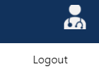



Description:

The system should allow registered users to log out securely.

4.1.3 Create Account

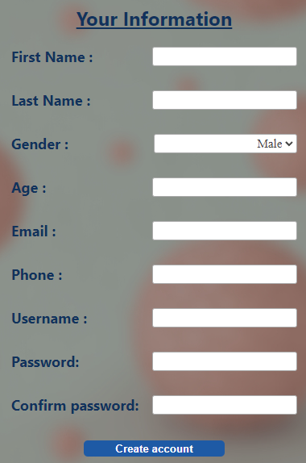

Description:

The system should provide a robust and user-friendly mechanism, empowering users to securely create and manage their accounts with confidence, ensuring the utmost protection of their personal information.

4.2 User: Doctor

4.2.1 Upload image for analysis

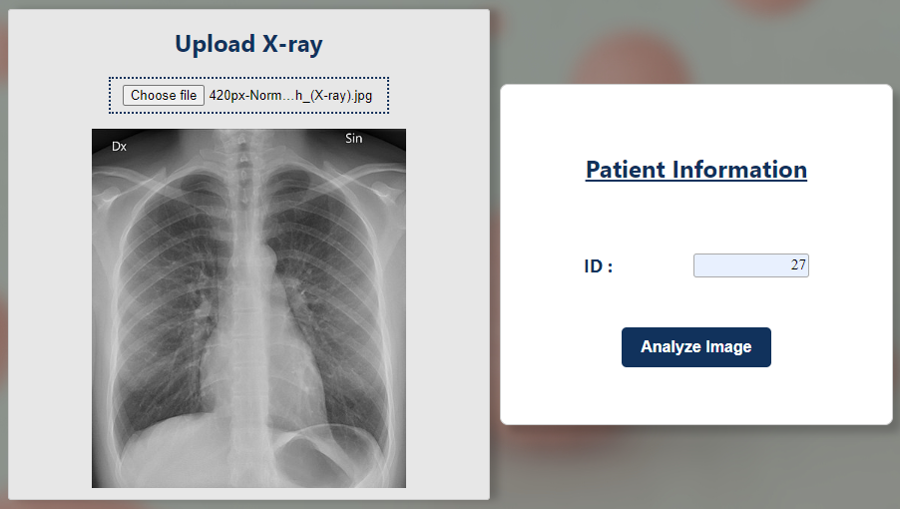

Description:

The page will allow doctors to upload an X-Ray of the patient and adding the Patient ID which is unique. The user can click on the “choose file” button where the user will be prompted to select an image file from the local device and once selected, the image will be displayed on the grey box as a preview.

Description:

After clicking on “Analyze Image”, the image will be processed once it is done all information will be collected and “Create Report” will show up upon successful detection and this will lead the user to DoctorViewResult page.

4.2.2 View analysis report

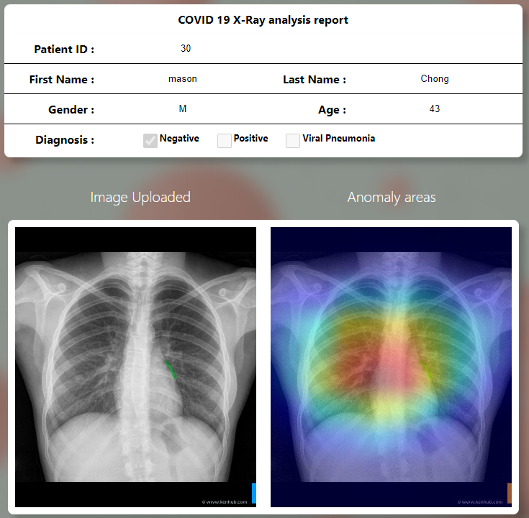

Description:

The page will display a COVID 19 X-Ray analysis report form, comprising of basic patients’ fields like “Patient ID”, “First Name“, “Last Name”, “Gender” and “Age”. And the result of the covid diagnosis will be indicated by a tick under positive or negative. The photo uploaded previously and a heatmap will be shown next. The purpose of the heatmap is to make a comparison of the grey scale x-ray image than aim to help the doctor to have a better analysis of the x-ray.

4.2.3 Write comments for patients



Description:

Doctors are able to possess the capability to write supplementary comments pertaining to the patient, thereby enhancing the comprehensive nature of the patient's healthcare records.

4.2.4 Submit comment/report



Description:

Doctors are able submit the report and comments for storage on the database.

4.2.5 View previously submitted report



Description:

Doctors are able to view the reports they have submitted previously.

4.2.6 Edit comment for previously submitted report.

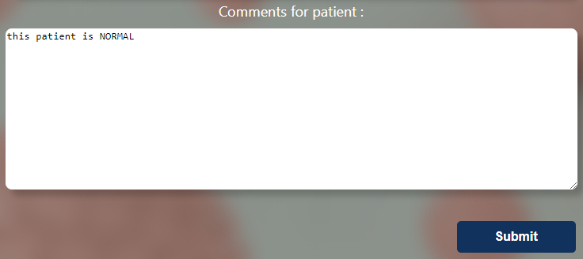

Description:

Doctors are able to edit the comments of the reports they have submitted previously.

3.2.7 Make report available to the corresponding patient

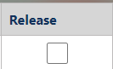 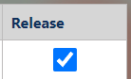

Description:

Doctors are able to release the report to the patient so the patient can carry out further actions.

4.2.8 Make report unavailable to the corresponding patient

 

Description:

Doctors are able to make the report unavailable to the patient.

4.3 User: Patient

4.3.1 View analysis report and comment from doctor

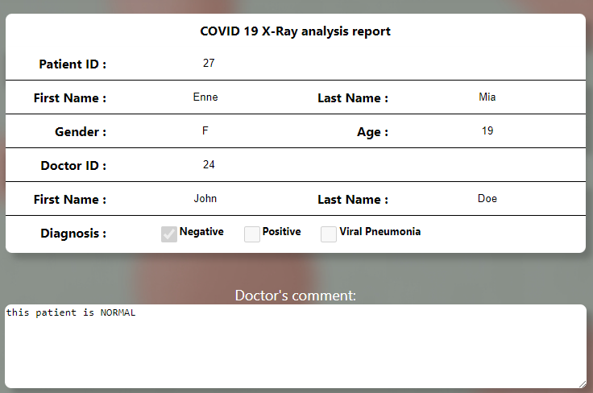

Description:

Patients have the ability to access and review both the report and the insightful comments provided by the attending doctor, offering a comprehensive and transparent understanding of their healthcare information as shared by the medical practitioner.

4.3.2 Save analysis report

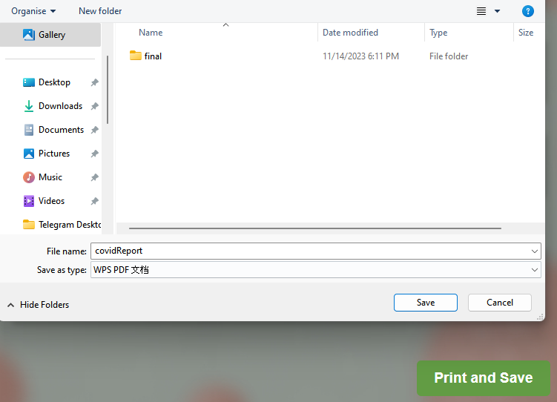

Description:

Patients are able save the analysis report.

# Test Plans

|  |  |  |  |  |
| --- | --- | --- | --- | --- |
| **User** | **Features** | **Scenario Description** | **Test Case ID** | **Status** |
| All User | Login | Existing app users must be able to successfully log in to their account | TC A1.1 | PASS |
| Login | User key in wrong username or password or both, error message appears to prompt re-entry | TC A1.2 | PASS |
| Login | User clicks on login button without filling in either username or password or both | TC A1.3 | PASS |
| Logout | When user hovers on right profile icon and clicks on logout under the navigation bar on any page, they will be successfully redirected to the login page and session token is removed | TC A2.1 | PASS |
|  |  |  |  |  |
|  | Main page  Dashboard | Doctor dashboard can display all records that was created by the doctor profile that is logged in. | TC B1.1 | PASS |
| Main page  Dashboard | Doctor can edit record comments by clicking on the edit icon on the dashboard and redirected to the doctorViewResult page to edit the comments. | TC B1.2 | PASS |
| Main page  Dashboard | Doctor can release report to patient by clicking on the release checkbox to a “Tick” to enable visibility of the report to the patients. | TC B1.3 | PASS |
| Main page  Dashboard | Doctor can hide report to patient by clicking on the release checkbox to “Un-Tick” to hide report from the patients. | TC B1.4 | PASS |
| Upload page | User hover on left navigation bar tab and clicks on upload will be redirected to upload page | TC B2.1 | PASS |
| Upload page | Doctor able to upload a valid X-ray image and existing patient ID and clicks on “Analyse Image”. Upon successful analysis, “Create Report” button will appear. | TC B2.2 | PASS |
| Upload page | Doctor clicks on analyse button with out uploading image and patient ID, 2 error messages will be displayed prompting to upload an image and fill in patient field. | TC B2.3 | PASS |
| Upload page | Doctor uploads X-ray image but did not fill in patient ID when clicking on “Analysis image” button, error message will be displayed prompting to fill in patient ID. | TC B2.4 | PASS |
| Upload page | Doctor did not upload X-ray image but fills in patient ID when clicking on “Analysis image” button, error message will be displayed prompting to upload an image. | TC B2.5 | PASS |
| Upload page | Doctor clicks on “Analysis Image” button but did not upload valid Xray image. Error message will prompt user to select a valid lung X-ray image. | TC B2.6 | PASS |
| Upload page | Doctor can create report by clicking on “Create Report” button and redirected to doctorViewResult page to view the full report that is created. | TC B2.7 | PASS |
| Doctor view result page | Doctor can view full report inside the doctorViewResult page | TC B3.1 | PASS |
| Doctor view result page | Doctor can add or edit comments, by clicking on the “Submit” button. A message will be displayed indicating comment successfully updated and redirect to main page. | TC B3.2 | PASS |
| Doctor view result page | Doctor clicks on “Submit” button but no changes were made, error message indicating no changes to save will be displayed. No changes made | TC B3.3 | PASS |
| Doctor view result page | Doctor clicks on “Submit” button and comment field is empty, error message comments cannot be empty will be displayed. No changes made | TC B3.4 | PASS |
|  |  |  |  |  |
| Patient | Create Account | Patient successfully create account, message showing account successfully created and redirected to login page | TC C1.1 | PASS |
| Create  Account | Patient enters firstName and lastName with numbers or symbols, error message will prompt user to only key in alphabets | TC C1.2 | PASS |
| Create  Account | Patient is not able to enter phone number with alphabets, symbols or more than 10 digits | TC C1.3 | PASS |
| Create Account | Patient will not be able to create new account if account, phone number, email or username already exist. An error message will be prompted indicating account already exist | TC C1.4 | PASS |
| Main page  Dashboard | Patient dashboard can display all records that was created by the doctor | TC C2.1 | PASS |
| Main page  Dashboard | Patient can view record by clicking on the eye icon on the dashboard and redirected to the patientViewReport page | TC C2.2 | PASS |
| Main page  Dashboard | Patient unable view record when clicking on the dashed eye icon on the dashboard. No action performed | TC C2.3 | PASS |
| Patient view report  page | Patient can view full report inside the patientViewReport page | TC C3.1 | PASS |
| Patient view report  page | Patient can print and save the report by clicking on the “print and save” button | TC C3.2 | PASS |